Timing Diagrams
# Source: AI Source: Provided by: [Data Path: Persons Table -> ID Column: 1, Name_En Column: Motasem Essam] -> From: [ChatGPT] on [1/21/2026]
Timing Diagrams are one of the common modeling techniques used in Real-Time Systems (RTS) to visually represent the timing behavior of tasks, events, and signals over time.

Definition
# Source: AI Source: Provided by: [Data Path: Persons Table -> ID Column: 1, Name_En Column: Motasem Essam] -> From: [ChatGPT] on [1/21/2026]
A timing diagram is a graphical representation that shows how signals, tasks, or events change with respect to time.
- Helps in analyzing task execution, synchronization, and deadlines.
- Shows start times, end times, execution durations, and delays.

Key Features
# Source: AI Source: Provided by: [Data Path: Persons Table -> ID Column: 1, Name_En Column: Motasem Essam] -> From: [ChatGPT] on [1/21/2026]
- Time on the Horizontal Axis
  - Time flows from left to right.
- Tasks or Signals on the Vertical Axis
  - Each line represents a task, process, or signal.
- Events or State Changes
  - Marked as transitions, pulses, or high/low signals.
- Deadline and Period Analysis
  - Easy to visualize if tasks meet their deadlines and periodicity.

Example
# Source: AI Source: Provided by: [Data Path: Persons Table -> ID Column: 1, Name_En Column: Motasem Essam] -> From: [ChatGPT] on [1/21/2026]
Suppose a real-time system has three tasks:
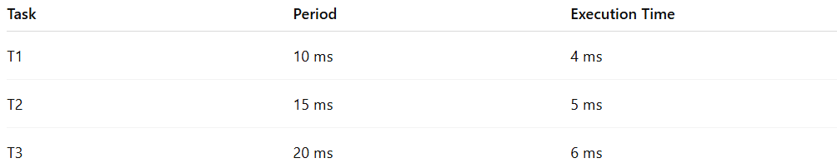
Task | Period | Execution Time
T1 | 10 ms | 4 ms
T2 | 15 ms | 5 ms
T3 | 20 ms | 6 ms
A timing diagram would show:
- T1 executes at 0–4 ms, 10–14 ms, 20–24 ms…
- T2 executes at 0–5 ms, 15–20 ms…
- T3 executes at 0–6 ms, 20–26 ms…
By plotting these on a timeline, you can check overlaps, preemption, and deadline compliance.

Advantages
# Source: AI Source: Provided by: [Data Path: Persons Table -> ID Column: 1, Name_En Column: Motasem Essam] -> From: [ChatGPT] on [1/21/2026]
- Provides a clear visual representation of task timing.
- Helps in detecting timing conflicts or missed deadlines.
- Useful for debugging and system design verification.

Disadvantages
# Source: AI Source: Provided by: [Data Path: Persons Table -> ID Column: 1, Name_En Column: Motasem Essam] -> From: [ChatGPT] on [1/21/2026]
- Can become complex with many tasks.
- Requires accurate knowledge of execution times and periods.

Applications
# Source: AI Source: Provided by: [Data Path: Persons Table -> ID Column: 1, Name_En Column: Motasem Essam] -> From: [ChatGPT] on [1/21/2026]
- Real-time operating systems task analysis
- Embedded systems design
- Automotive and avionics systems
- Industrial automation

